CLASSIFIED STAFF NEEDS ASSESSMENT APPLICATION
Name of Person Submitting Request: | Celia Huston
Program or Service Area: | Library & Library Lab
Division: | Library and Learning Resources Division
When was the last Program Efficacy document completed? | Fall 2009
What rating was given? | Continuation
Current number of Classified Staff: | FT | 8 | PT
Position Requested | Library Media Clerk (note: this is in addition to the position on the Ad-Hoc SERP Committee list)

- Provide a rationale for your request.
Library Media Clerks staff the Circulation Desk and the Computer Lab Desk. Library Media Clerks perform a variety of routine clerical duties in support of the various sections/functions of the library: check materials in and out of the library; provide general assistance to students in the library and computer lab; distribute library cards; collect fines as necessary; and provide interlibrary loan services between campuses.

- Indicate how the content of the EMP One-Sheet and latest Program Efficacy Report support this request. How is the request tied to program planning? (Reference the page number(s) where the information can be found on the EMP and Program Efficacy).

The Library and Computer Lab have not been included in the current Educational Master Plan, but will be included in the next plan update. The Library and Computer Lab track a variety of statistical data. Data that reflects library staff’s direct interactions with students that includes library circulations and Computer Lab check-outs.

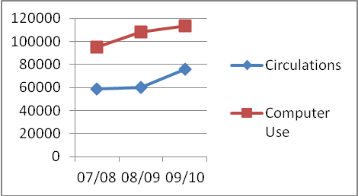 | 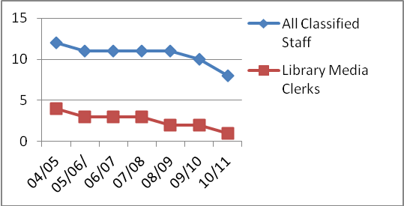

Library use continues to climb while library staff continues to decline resulting in long lines, less student service and a 23% reduction in service hours and closure on Saturdays.

- Indicate if there is additional information you wish the committee to consider (for example: regulatory information, compliance, updated efficiency and/or student success data or planning etc).

- The 23% reduction of Library and Computer Lab days and hours of service in 09/10 is directly tied to the Library Media Clerk position that was not replaced in the 08/09 school year. In June 2010, another Library Media Clerk retired. From five full time clerks in 2004, the Library now has one (with another position filled with a substitute until it can be filled full time).
- Computer Technicians are doing clerical work at the Computer Lab desk instead of working one-on-one with students in the Lab. Now, one Computer Technician has been taken from the Library and moved to the Campus Technology department. Although this may help that department, it does nothing but cause more problems for the Library and Learning Resources division and the students we serve.
- The Circulation Supervisor is doing clerical work at the circulation desk in addition to managerial responsibilities. She arrives early and stays late in an attempt to get all of her own work done.
- Library Technicians are doing clerical work at the circulation desk instead of processing new library materials such as textbook reserves, new books, current journals, magazines and newspapers
- The Library and Learning Resources Division have been approved and ranked for a Library Media Clerk for the past two needs assessment cycles, but the position has not been filled.
- Student Surveys received at the Reference Desk have noted that the reduced library hours and closure on Saturdays interferes with their learning.

- Evaluation of related costs (including any ongoing maintenance or updates) and identification of any alternative or ongoing funding sources. (for example Department Budget, VTEA or Perkins)

Entry level salary is 29,888 annually, plus benefits. Position funding would be ongoing.

- What are the consequences of not filling this position?
Even when the Ad-Hoc SERP replacement position is hired the Library and Computer Lab will only have 2 Library Media Clerks (80 total hours) to staff two service desks that are open 57 hours a week each (114 total hours). This has been done since 2008/2009 at the expense of library service hours and other library processes. Computer Technicians are unable to assist students with the computers because they are doing the work of a Library Media Clerk. New library materials, journals and newspapers, many of which are time sensitive, are delayed because Library Technicians are doing the work of a Library Media Clerk. Without a 3rd Library Media Clerk,the Library and Computer Lab will continue to have fewer hours of service, very long lines, limited student services and an imbalance in the library infrastructure that causes the library to run inefficiently.

